The Union Customs Code (UCC)
Malta Customs has been working to upgrade its current IT systems and introduce new systems for further trade facilitation and to fulfill the provisions of the UCC that is to provide a paperless system for customs formalities. The Union Customs Code (UCC) envisages the use of Information Technology for all customs related formalities. It shall be mandatory to use electronic processing techniques for the exchange and storage of information between:
- Customs authorities
- Customs authorities and Economic Operators
By 2025 there should be a uniform application of the UCC across all Member States including the use of internationally accepted data models and message formats. For this purpose, the EU Commission has set out its plans and timescales for IT development in:
- https://taxation-customs.ec.europa.eu/customs-4/union-customs-code/ucc-work-programme_en (The UCC Work Programme); and
- https://taxation-customs.ec.europa.eu/customs-4/electronic-customs_en Multi Annual Strategic Plan (MASP)
These documents are being regularly updated by the EU Commission.

Information on the new system AN-PN-TS that will be replacing the current Manifest system.
This information aims to help economic operators and customs officials introduce and implement the new IT system AN-PN-TS. This change is necessary to ensure that Malta together with all the other Member States forming the Customs Territory of the Union, is ready to fully implement the provisions of the Union Customs Code (UCC) by 2025.

What is the role of Malta Customs in the importation process?
All goods imported into Malta must be declared to Customs in advance of their arrival through the ICS2 (Import Control System) by submitting the ENS (Entry Summary Declaration). It is the duty of customs to make sure that any goods declared for import are moving legally and are not subject to any prohibitions and restrictions.

What will replace the current manifest?
When Malta is the first port of call for goods coming from third countries, ship or airline carriers/representatives shall lodge an Entry Summary Declaration (ENS) in the Import Control System (ICS2).
The ENS lodged by the carrier is an electronic Safety and Security declaration which must be lodged before the goods arrive. This declaration must be lodged at the office of first entry in the customs territory of the Union.
When the goods are declared in ICS2 an MRN (Master Reference Number) is generated.

Arrival Notification (AN)
The Carrier or representative of a sea-going vessel or of an aircraft entering the customs territory of the Union shall notify the arrival of the means of transport to the customs office of first entry into the EU.
The Arrival Notification must be lodged in ICS2. Subsequently, an MRN is generated to be used in the next stage of the process.

Presentation Notification (PN)
The customs authority must be informed about the fact that the goods have arrived and are available for presentation to customs. A Presentation Notification shall be lodged in the AN-PN-TS system and should contain the MRN of the previously lodged Entry Summary Declaration (ENS).

Temporary Storage (TS)
Non-EU goods brought into the customs territory of the Union are in Temporary Storage from the moment they arrive and are presented to customs until they are placed under a customs procedure or re-exported. The MRN from the Presentation Notification is mandatory for the acceptance of a Temporary Storage Declaration (TSD). It would be possible for EOs to make a pre-lodged TSD before the means of transport arrives in Malta.
Goods in Temporary Storage:
- are under customs supervision;
- cannot be moved without customs authorisation; and
- cannot be processed.
To remove goods from Temporary storage, they must be:
- placed under a customs procedure;
- re-exported; or
- destroyed within a maximum of 90 days.

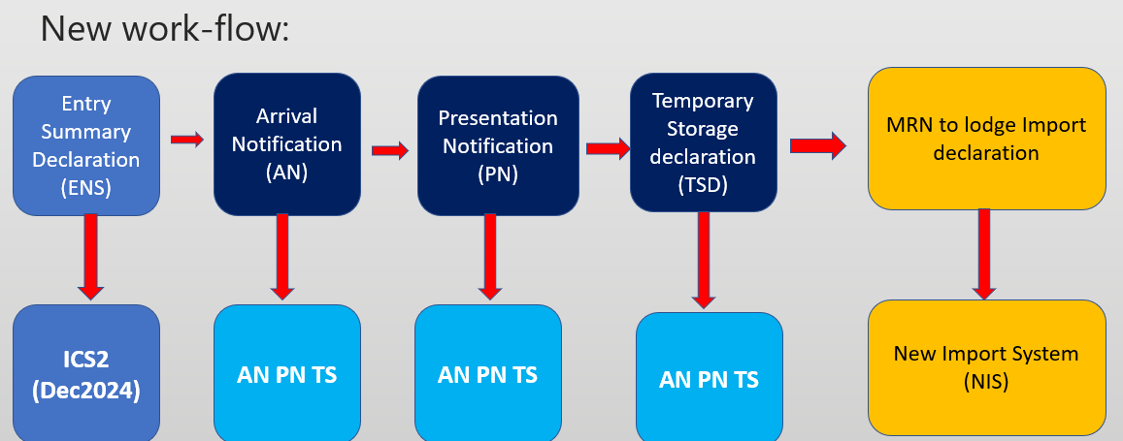

Who can lodge an AN, PN & TS?
Arrival Notification:
The carrier or his representative must inform the customs office of first entry of the arrival of the means of transport.
Presentation Notification:
- The person who brought the goods in the customs territory of the Union;
- The person in whose name or on whose behalf the person who brought the goods in the territory acts;
- The person who assumed responsibility for carriage of the goods after they were brought into the Union;
- Any person who immediately places the goods under a customs procedure;
- Free zone operator.
Temporary Storage Declaration
Same as persons lodging the presentation notification.

Temporary Storage declaration
A TSD can be lodged prior to the presentation of the goods.
A pre-lodged TSD allows economic operators to lodge the declaration prior to the expected presentation of the goods to the customs authorities. Upon the goods' arrival, a PN must be lodged to activate the pre-lodged TSD.
If goods are not presented to customs within 30 days, the pre-lodged declaration will be automatically invalidated.
Entry of Goods in Malta
Economic operators shall follow a five-step process to declare goods under a customs procedure.
- Lodgment of ENS in ICS 2
- Notification of the arrival of the means of transport (AN)
- Presentation of the goods (PN)
- Temporary Storage declaration of goods (TSD)
- Placing goods under a customs procedure (CD)

What is a temporary storage facility?
A temporary storage facility (TSF) is a Customs approved place inside or outside the approved area of a sea or airport, where non-Union goods are placed in storage prior to being placed under a customs procedure or re-exported. The facility must be authorised by the customs authorities as a temporary storage facility. Non-union goods can remain in a TSF for 90 days.

How to apply for the authorisation of a Temporary Storage Facility.
Economic operators (EO) are requested to fill in a national ‘CDS Application Form’ and forward it to the Customs Temporary Storage Monitoring Unit (TSMU) so that they will be provided with log in credentials to gain access to the EU Trader portal.
Then the EO shall fill in the application for TSF through the EU Trader Portal and submit it. Once submitted, TSMU will receive a notification to process the application.
Once the application is accepted and approved, an authorisation number will be allocated to that TSF. The TSF warehouse number must be declared in every temporary storage declaration for goods being stored there.

EU Customs Data Model (EUCDM)
The EU Customs Data Model represents the data requirements specified in the EU customs regulations in a data model. It is thus the implementation of the customs code and the model for trans-European systems such as NCTS, AES, ICS, EOS and for the national clearance systems of the EU Member States. Its overall objective is to provide a common methodology and approach that models the data requirements according to the Union Customs Code (UCC)
More information on the EUCDM can be found on the following webpage: https://taxation-customs.ec.europa.eu/customs-4/union-customs-code/eu-customs-data-model-eucdm_en

The codes for the AN, PN and TS are:
G2 | Arrival Notification
G3 | Presentation notification
G4 | Temporary storage declaration
G5 | Arrival notification

Further information
For more information you may contact TSMU (tsmu.mtca@gov.mt).

